**Porterville College Mission Statement**:

With students as our focus, Porterville College provides our diverse local communities quality education that promotes intellectual curiosity, personal growth, and lifelong learning, while preparing students for career and academic success.

In support of our values and philosophy, Porterville College will:

1. Provide quality academic programs to all students.
2. Provide comprehensive support services to help students achieve their personal, career and academic potential.
3. Prepare students for transfer and success at four-year institutions.
4. Provide courses and training to prepare students for employment or to enhance skills within their current careers.
5. Provide comprehensive support systems tailored to each student’s skill level.
6. Recognize student achievement through awarding degrees, certificates, grants, and scholarships.

**Guided Pathways Framework**:

1. Clarify the Path: Create clear curricular pathways to employment and further education.
2. Enter the Path: Help students choose and enter their pathway.
3. Stay on the Path: Help students stay on their path.
4. Ensure Learning: Ensure that learning is happening with clear outcomes.

**Program Mission Statement**:

The mission of the CalWORKs program is to assist students and their families who are challenged with social and economic barriers to achieve self-sufficiency through higher education and training; to offer career opportunities through collaboration and advocacy with our college and community partners and encouraging the enrollment; and to support retention and transfer of our students to expand their human potential and enrich the quality of their lives.

(Note that this program mission statement is linked to the Office of Student Services Vision, Mission, and Values Statement; therefore, CalWORKs supports the same vision, mission and values as the whole division.)

**Service Area Outcomes (SAOs)**:

|  |  |  |
| --- | --- | --- |
| SAO Statement  NEW | Describe assessment results and discussion of this SAO | Describe how the results impact your goals and needs going forward |
| **Students enrolled in the CalWORKs program will be able to identify their individual responsibility within the program resulting in successfully complying with program requirements.** | The CalWORKs program will assess students completing the required Intake Checklist and Pre-test within two weeks before classes begin. The SAO will be assessed in a three-year cycle. The new SAO cycle will begin in Spring 2025. Counselors conducting the Checklist Intake will be responsible for collecting SAO data, 70% of the students who complete an intake must demonstrate satisfactory knowledge. |  |
|  |  |  |

***SAO Results***

There are no documented SAOs since 2020.

**Program Analysis and Trends**:

***Data Review***

*Table A:*

*Table A* outlines the data for CalWORKs participants in comparison to participants not enrolled in the CalWORKs program over the past five years. Based on the data shown above, during the 2020-2021 and 2021-2022 academic years, CalWORKs participants showed a decline. In 2022-2023 the percentage remained steady. In 2023-2024, CalWORKs participants have shown an increase in success rate and continuous improvement.

*Table B:*

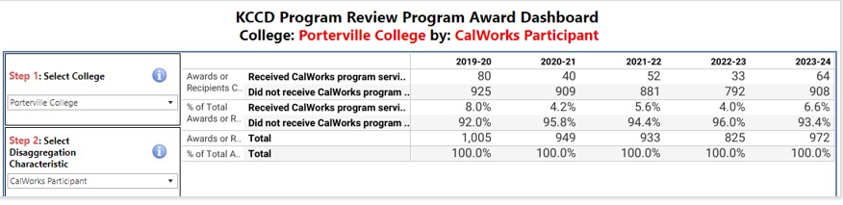

*Table B* demonstrates the number of awards conferred for CalWORKs program participants in comparison to participants not enrolled in the CalWORKs program over the past five years. Based on the data shown in *Table B,* CalWORKs participants experienced a decrease in awards conferred in the academic year 2020-2021. Awards conferred increased in the 2021-2022 academic year but again decreased in the 2022-2023 academic year. In the most recent year 2023-2024, CalWORKs participants have shown an increase on conferred awards, similar to data results from 2019-2020.

*Table C:*

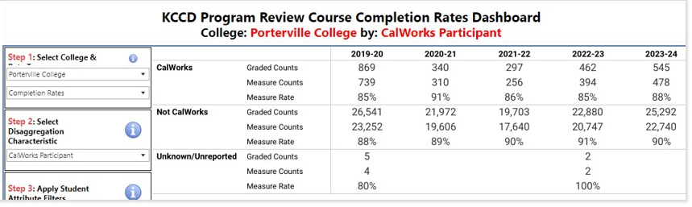

*Graph C:*

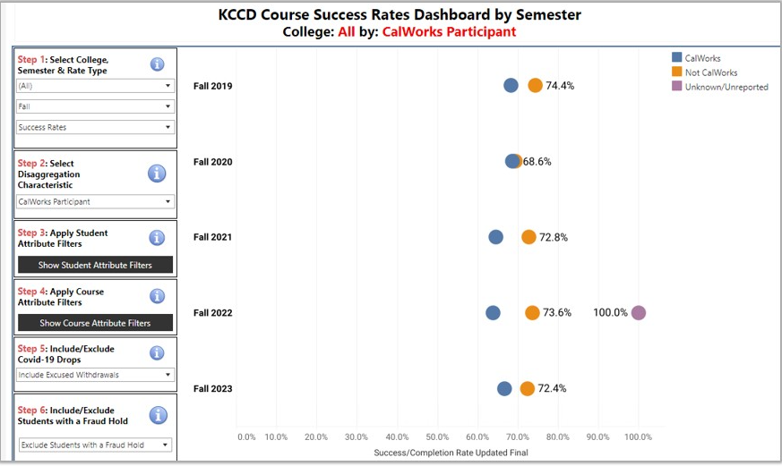

*Table C* and *Graph C* above show 3 terms of completion rates for CalWORKs participants compared to non-CalWORKs participants. **Success Rates** are the percentage of participants who successfully complete a course with a grade of (A, B, C, SP, or P). Based on the data shown in *Table C* and *Graph C,* CalWORKs participants were as successful as non-CalWORKs participants with slight gaps in rates. However, based on the data shown above CalWORKs participants have shown a decline in success/course completion rates and increase in the gap comparison to non-participant CalWORKs students in the 2021-2022 and 2022-2023 academic years. In the 2023-2024 academic year, CalWORKs participants completion rates have increased in comparison to non-CalWORKs and have shown to close the gap between non-CalWORKs and CalWORKs participants.

***Changes in Program over Last Three Years***

The Porterville College CalWORKs program is working diligently to recover from the COVID-19 pandemic. Students and the program team adapted to an online environment and now moving back to face-to-face interactions. CalWORKs students transitioned from attending classes in person to studying in their home with children in the background. Some experienced internet service issues resulted in students not being able to connect with their course or instructor. Parents still had the fear of leaving their home, contracting COVID-19, and exposing their children to the virus.

The COVID-19 pandemic brought a decline in participation in our TulareWORKs program. This program provides work experience opportunities in the field related to the student’s interest. As courses were returning to campus students still feared contracting COVID-19 and there was a lack of work sites available. The program reopened during 2021, but the obstacles outlined were still present causing a lack of interest by CalWORKs students.  As of July 1, 2024, the Tulare- Works contract ended due to lack of students and businesses participating.

The passage of SB 1232 brought a major change to the way we administered our CalWORKs program and how students receive their educational benefits. The first major update was in how we verified the units and Education Plans for each student. The previous workflow required ongoing review of each student’s schedule to confirm they are only enrolled in approved courses for their major. The new policy only requires that the units are verified, not the courses. Books were previously issued using a book voucher that the student would use in the Porterville College Bookstore. The new policy eliminates that process and simply issues an award to the students after course units are approved.

***Report on Previous Goals***

|  |  |
| --- | --- |
| Goal | Status/Progress |
|  |  |
| 1. Update the policies and  procedures manual | This is on-going as changes are made to the office workflow and structure. |
|  |  |

***Program Strengths***

The strengths of the CalWORKs program include offering students quality support services and a supportive learning environment while developing community partnerships for the benefit of students and promoting positive campus working relationships.

The program has ongoing professional development opportunities for the team that focuses on community resources and customer service, so they are always adapting their approaches to the student needs. Student needs are assessed and barriers are addressed creating a supportive learning environment that helps students as they progress through their education plans. The team’s involvement in campus activities promotes positive working relationships with other departments on campus. These partnerships create a campus safety net ready to help students in all areas.

***Areas for Improvement***

One area the CalWORKs program strives to improve is developing a stronger rapport with county partners by encouraging open and consistent communication and collaboration. Currently, county partners and the Porterville College CalWORKs team meet twice each semester. Collaboration includes one meeting in the CalWORKs Program Advisory Committee meeting and one meeting through a scheduled meeting via Zoom with the TulareWORKs County partners. Both meetings greatly benefit the Porterville College CalWORKs team and our county partners as they share best practices, updates or changes to the program, and discuss strategies to improve how students are supported.

To better strengthen our collaboration with our county partners, Porterville College CalWORKs has explored the option to invite a TulareWORKs county caseworker to meet on campus with Porterville College CalWORKs participants. This collaboration would offer more accessibility to CalWORKs participants to meet with a county caseworker regarding any immediate questions or concerns. This collaboration would strengthen communication between our TulareWORKs partners and the Porterville College CalWORKs team especially if any changes had been made with county services and regulations that may affect Porterville College CalWORKs program.

**Goals**

|  |  |  |  |  |  |
| --- | --- | --- | --- | --- | --- |
| Goal(s) | Timeline for completion | Needed resources | Person(s) Responsible | Obstacles to completion | Guided Pathways Pillars |
| 1. Increase persistence by 5% points | Fall 2026 | Data & Direct Aid Funding | Counselors  Director | Student’s financial instability and childcare | 3. Stay on the Path |
| 2. Increase course student success by 5% points | Fall 2026 | Data & Direct Aid Funding | Counselors  Director | Student’s financial instability and childcare | 3. Stay on the Path |
|  |  |  |  |  |  |

**Staffing:**

***Current Staffing Levels***

|  |  |  |  |
| --- | --- | --- | --- |
| Full-time | | Part-time | |
| Faculty | 2 counselors | Faculty | 1 adjunct counselor |
| Temporary |  | Temporary |  |
| Classified | 2 Dept Assistants  2 Program Techs (works for DRC and EOPS) | Classified |  |
| Management | 1 Director | Management |  |

***Request for New/Replacement Staff***

Use one line for each position requested. Justify each position in the space below.

|  |  |  |  |  |
| --- | --- | --- | --- | --- |
|  | Title of Position | Classification  (Faculty, Classified, or Management) | Full- or Part-Time | New or Replacement |
| Position 1 | None |  |  |  |
| Position 2 |  |  |  |  |
| Position 3 |  |  |  |  |

Justification:

No additional request

**Resource Requests**

The following four sections are for requesting resources, such as technology, facilities, safety/security, and professional development. Please include all needs, even if you already have identified funds for them. Requests made here should be linked to needs identified in earlier sections (outcomes, areas for improvement, goals). If you have no needs in a particular area, just type NA.

TECHNOLOGY REQUEST

Use this section to list any technology needs for your program. If you have more than two technology needs, add rows below.

|  |  |  |
| --- | --- | --- |
|  | Technology Need | Justification |
| Item 1 | None |  |
| Item 2 |  |  |

FACILITIES REQUEST

Use this section to list any facilities needs for your program. If you have more than two facilities needs, add rows below.

|  |  |  |
| --- | --- | --- |
|  | Facilities Need | Justification |
| Item 1 | None |  |
| Item 2 |  |  |

SAFETY & SECURITY REQUEST

Use this section to list any safety & security needs for your program. If you have more than two safety & security needs, add rows below.

|  |  |  |
| --- | --- | --- |
|  | Safety/Security Need | Justification |
| Item 1 | None |  |
| Item 2 |  |  |

PROFESSIONAL DEVELOPMENT REQUEST

Use this section to list any professional development opportunities you would like to have available for your program. If you have more than two professional development needs, add rows below.

|  |  |  |
| --- | --- | --- |
|  | Professional Development Need | Justification |
| Item 1 | CalWORKs Annual Conference | To keep current on new program rules and regulations |
| Item 2 |  |  |

**Budget: CalWORKs**

(Please include all budget needs, even if your program is funded entirely by categorical funds. Do not include staffing in this section.)

|  |  |  |  |
| --- | --- | --- | --- |
|  | Current Budget | Amount of Change | Revised Total |
| 2000 (Student Workers Only) | 0 | 0 |  |
| 4000 Supplies and Materials | $4,891.30 | 0 |  |
| 5000 Operating Expenses and Services (Travel, Training, Software, etc.) | $11,500 | 0 |  |
| Other (Other Student Aide (non-cash) | $12,000.00 |  |  |

**Budget: TANF**

(Please include all budget needs, even if your program is funded entirely by categorical funds. Do not include staffing in this section.)

|  |  |  |  |
| --- | --- | --- | --- |
|  | Current Budget | Amount of Change | Revised Total |
| 7000 Grants | $15,000.00 | 0 |  |

Justification:

No additional request