Co-Chairs: Thad Russell, Kendra Haney, Kristi Covington

MINUTES

Present: Primavera Monarrez, Thad Russell, Michelle Miller-Galaz, Erin Wingfield, Reagen Dozier, Melissa Long, Nick Griffith, Rebecca Baird, Fernando Jimenez, Michael Carley, Marie Braidi, Stephanie Cortez, Chris Ebert, Kendra Haney, Matt Flummer, Patty Serrato, Kim Behrens, Elizabeth Keele, Vickie Dugan, Ethan Hartsel, Jeff Keele, Kristi Covington, Amy Tanguma, Kristen Plunk, Griselda Aceves, Tashina Pearson, Manuel Caceres, Osvaldo Del Valle, Erin Wingfield, Stephanie Olmedo-Hinde, Leo Espinoza, Keith Ford, Tiffany Haynes, Kim Behrens, Jasmin Quinones, Selena Monzon.
Absent: Jacob Sandoval, Ian Onizuka, Tiffany Haynes, Roger Perez.
Guest: Diane Thompson
Call to Order at 3:02 pm by Kendra Haney.
- Adoption of Agenda: Jeff Keele asked for follow up regarding the Flyer Posting Policy Update. Stephanie Olmedo-Hinde asked for report change in reporting individual for Disability Resource Cener Program Review. Approval of agenda with addition and change. M/S/C: Ethan Hartsell/Elizabeth Keele.
- Approval of Minutes: M/S/C: Elizabeth Keele/Ethan Hartsell.
- New Business-Announcement/Information/Discussion Items
  - ILOs (Melissa Long)
Melissa Long reviewed ILO #3 Information Competency asked for clarification on action plans brainstorming that was developed during the last council meeting.
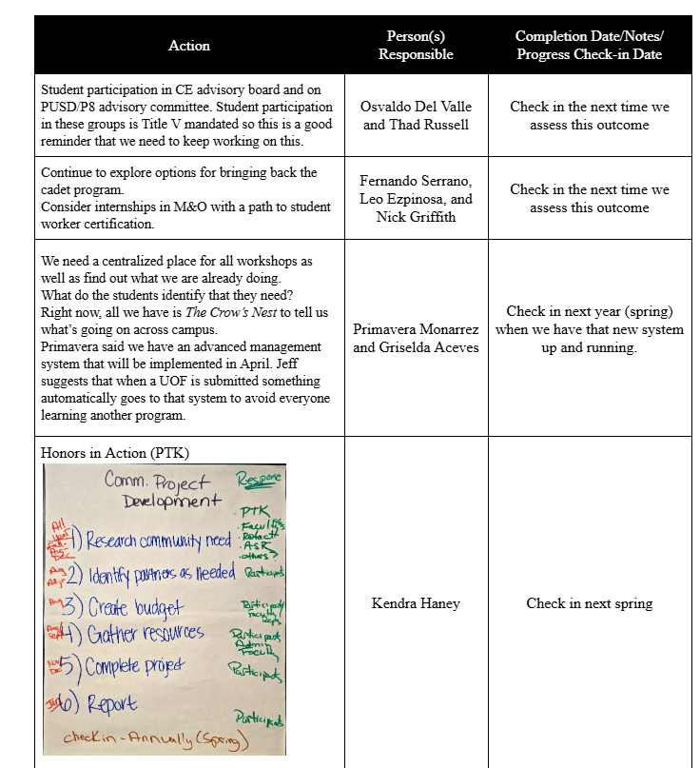
ILO #4 Social and Cultural Responsibility was reviewed with council with the ask of if it should stay the same or be changed.
  - Food Services Analysis/Proposal (Griselda Aceves)
Griselda Aceves reviewed the food services department proposal with council. Food services historically has been funded by general fund, yet within the last several years it has been funded through Covid funds which are not longer available causing funding to revert to general funding. Currently food services are being sources out to a third-party company. Low revenue increase of only 2.62% in 2024/2025 significant decrease from a 20.36% in 2023/2024 and 40.40% in 2022/2023 is showing that this is not sustainable. Over the last several months the cafeteria has been closed on multiple occasions and use of catering has significantly declined. Proposal is to internalize the food services by hiring a food services manager who will also be a chef and utilize student workers who will be paid out of revenue and GU001. Concerns of participatory governance were brought up regarding this. Students will be surveyed for their wants and needs and data will be included into final proposal. Proposal will be presented to budget committee and will return to college council for approval after completed.
  - Student Equity Plan Update (Jasmin Quinones)
Jasmin Quinones presented the Student Equity plan for the next cycle. This will be brought to College Council in September and October for first and second reads prior to final submission in November 2025.
  - Key Card Access (Stephanie Cortez)
Stephanie Cortez asked for clarity on who can be issued keycards and what is the process for receiving key cards. This is becoming problematic in CE with both on and off campus locations. Adjuncts are not being provided keycards, yet they need to access classrooms and have formal identification. Primavera Monarrez responded with the formalized process is being developed. First stage will be to roll out keycards to current faculty first and then adjuncts will be issued cards once a formal procedure is finalized. Griselda and Manual are working on streamlining this process with a timeline of being presented to President and Academic Senate in March 2025. Keycards will be limited to specific classrooms and times but it the issue of room changes, and lab prep arose.
  - Athletic Facilities (Primavera Monarrez)
Primavera Monarrez updated council on locker room area of concern regarding privacy issues in the locker rooms and coaches’ offices. There is a Title 9 issue that must be addressed. 6.5 million dollars was approved for phase one by board to update these areas to meet compliance. Athletics is being consulted on how to rectify this problem since the layout cannot be changed.
  - Accessibility Committee Membership (Thad Russell)
Thad Russell reminded council that he will be reaching out to each constituency group and ask them to be ready to dedicate someone to this committee.
  - Flyer Posting Policy Update (Erin Wingfield)
Erin Wingfield updated council that this is at legal and once there for formal legal feedback it will be brought back to College Council. The stamping process was questioned. It was strongly suggested that policy include determination on who can take down flyers if they do not agree with the content. It was suggested that instead of a poster posting policy that the development a freedom of expression/speech policy is created with posters that showcase this like at UC Riverside or UC Berkeley. Policy is still in development, and nothing has been implemented.
- Action Items-First Read
- Action Items – Second/Final Approval
  - Disability Resource Center Program Review (Stephanie Olmedo-Hinde)
M/S/C: Elizabeth Keele/Manual Caceres.
  - Language Arts Program Review (Melissa Long)
M/S/C: Vickie Dugan/Stepanie Cortez.
  - Office of Instruction Program Review (Thad Russell)
Tabled.
  - Athletics Program Review (Keith Ford)
Tabled.
- Subcommittee reports
  - Accreditation (Thad Russell)
Currently in accreditation cycle. Request for additional data should be sent today. There will be an accreditation meeting next week.
  - Accessibility
No committee developed at this time.
  - Budget (Griselda Aceves)
Absent.
  - Strategic Planning (Michael Carley)
Feedback on Strategic Plan has been implemented. Final draft should be ready for College Council in April 2025.
  - Enrollment Management (Thad Russell)
Recap of Scheduling Summit concerns. Enrollment Management plan and strategy to get that completed.
  - Guided Pathways (Erin Wingfield)
Scheduling Summit successful turnout. Review of feedback is being complained to be implement moving forward, adult learners master plan and committee goals are under review.
  - Information Technology (Manual Caceres)
Java application must be removed from every computer on campus. There are only 23 applications on campus. Windows 11 will be rolling out in the fall 2025. Instructional technology updates will be led by Debbie Lou Angeles.
  - Facilities Planning Advisory (Primavera Monarrez)
Facility project updates include athletics, road construction, and CE building charge is being updated and will be brought to future College Council.
  - Safety and Security Team (Leo Espinoza)
Red bag trainings are being revamped. Safety and Security forum will occur this month.
  - Social Justice Action (Jasmin Quinones)
The SJAC team has been having discussions on things happening on the National Level. There is also a small group of individuals who are joining the Leading from the Middle Conference. There will be a consultant joining us in the Fall to provide Cultural Competency Trainings to our students and staff.
  - Staff Development (Jasmin Quinones)
No report.
- Other Reports
  - President
Consensus around campus is that people are overwhelmed and concerned about what is occurring nationally, district-wide, and on campus. Multiple gaps in areas that have not been previously addressed are now being brought to the table and will be addressed as timely as possible.
  - Academic senate
Senate met on Friday February 28. Leo and Griselda came to discuss safety and security concerns with the Senate. Senate and Curriculum are working on a process to create courses with multiple disciplines in the COR. The Distinguished Students Awards will be Friday April 25 at 5pm. The nomination form for the annual Phronesis Award has gone out and is due by March 31st.
  - Outcomes
Reminder of ongoing participation in Outcomes Fest. If working on program reviews, please reach out regarding outcomes prior to sending to Strategic Planning.
  - CCA
No report.
  - CSEA
Negotiations are ongoing. Working on membership engagement and increasing communication.
  - ASPC
Mascot name and events planned for Spring Fling. Delivery of diplomas, and tutoring centers on the back side of campus are not being utilized because they are so far back, and students are not aware have been brought to ASPC’s attention.
- Additions
- Future Agenda Items
Food Services Proposal, Flyer posting, Strategic Plan, Office of Instruction program review, Athletics program review.
- Adjournment.
Meeting adjourned at 4:59 pm.

