**Participatory Governance**

**Structure**



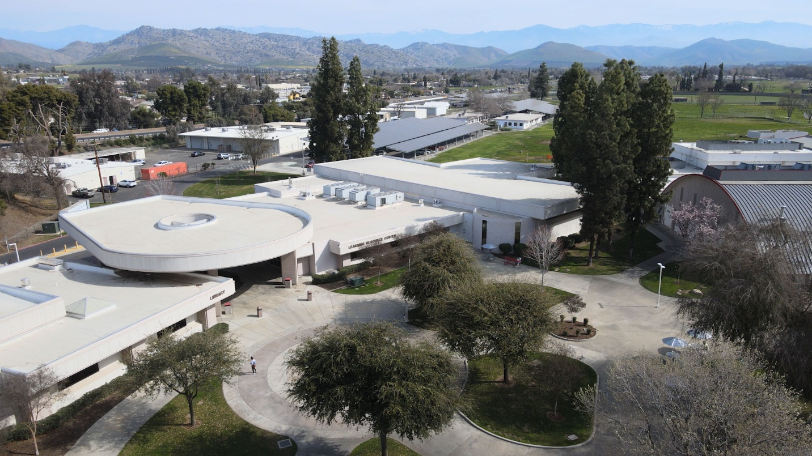

**Participatory Governance at Porterville College**

**Our Mission**

With students as our focus, Porterville College provides our diverse local communities with quality education that promotes intellectual curiosity, personal growth, and lifelong learning, while preparing students for career and academic success.

In support of our values and philosophy, Porterville College will:

* Provide quality academic programs to all students.
* Provide comprehensive support services to help students achieve their personal, career and academic potential.
* Prepare students for transfer and success at four-year institutions.
* Provide courses and training to prepare students for employment or to enhance skills within their current careers.
* Provide comprehensive support systems tailored to each student's skill level.
* Recognize student achievement through awarding degrees, certificates, grants, and scholarships.

**Our Values**

Porterville College's core values define the character of the institution and are active ingredients in all that the College does. Through our commitment to these values the College can better serve and be more responsive to its students, staff, and community:

**P**articipation - fostering and encouraging the involvement of staff and students in campus activities and the various aspects of the College decision-making process.

**I**ntegrity - holding one another accountable and remaining transparent by adhering to the highest academic and professional standards.

**R**espect - treating each other with respect, trust, and dignity.

**A**daptability - nurturing and supporting exploration of innovative ideas, programs, and services to enhance our service to the community.

**T**eamwork - working together to encourage input and dialogue in a collegial and cooperative manner.

**E**quity - Supporting students in achieving their full educational potential regardless of race, ethnicity, age, gender, gender identity, sexual orientation, immigration status, religion, ability, culture, and learning modality.

**S**uccess - Striving to continually support students in achieving their academic, career, and personal goals.

**Our Philosophy**

In support of our mission and values, Porterville College will base its decisions and actions upon the following beliefs:

* All students at Porterville College will be treated with respect and dignity regardless of who they are or the goals they have established for themselves.
* Porterville College will provide the best possible service to its students in order for them to meet their individual academic or vocational goals.
* Porterville College will encourage innovation, creativity, and new ideas and will support professional development opportunities.
* As an integral part of the community, Porterville College will develop and enhance partnerships with schools, colleges, universities, businesses, and community-based organizations to respond to the educational, workforce, and economic development needs of the region.
* As an integral part of the Kern Community College District, Porterville College will participate in and be actively involved with all district-wide committees and governance structures.

**Philosophy of Participatory Governance**

### *Terminology and Legal Authority in Participatory Governance*

Pursuant to **Education Code Section 70902(b)(7)**, the **California Community Colleges Board of Governors** is statutorily mandated to promulgate regulations ensuring that faculty, staff, and students are afforded the **right to participate effectively** in the governance of both district and college affairs. The **Title 5 regulations** of the **California Code of Regulations**, which operationalize this statutory directive (see Appendix A), explicitly require that governing boards **“consult collegially”** with the **Academic Senate** on **academic and professional matters**. Moreover, these regulations stipulate that classified professionals, administrators, and students must be provided with the opportunity to participate effectively in the formulation of procedures and recommendations that have a demonstrable impact on their roles within the institution (see Local Practice under Title 5 below). Collectively, these Title 5 provisions establish the regulatory framework governing participatory governance across all California community colleges.

It is critical to note that the term "participatory governance" does not exist within statutory law or formal regulatory provisions. Instead, it serves as a conceptual framework for delineating institutional processes that engage various constituency groups—including faculty, staff, administrators, and students—in institutional planning and decision-making. Furthermore, the term "governance" also encompasses the fiduciary and policymaking responsibilities vested in the College’s Board of Trustees. Institutional policies and procedures that affirm the rights of constituency groups to participate effectively in governance through advisory recommendations to the Board do not, however, diminish, supersede, or encroach upon the governing authority of the Board. Nor do they negate or subordinate the decision-making prerogatives of the President, who remains directly accountable to the Board of Trustees for the consequences of all administrative and policy decisions.

At Porterville College, all participatory governance committee recommendations are advisory in nature and are directed to the President, who retains final decision-making authority and serves as the primary conduit for policy recommendations to the District Chancellor who makes final recommendations to the KCCD Board of Trustees. The President, in concert with their executive leadership team (Cabinet), functions as the principal liaison between the Chancellor and the college’s constituency groups.

This section provides a foundational overview of participatory governance within the California Community Colleges system and does not endeavor to encapsulate the full complexity of the legal and regulatory landscape that governs such processes. Readers seeking a comprehensive legal analysis are encouraged to consult the relevant sections of the Education Code, Title 5 of the California Code of Regulations, and supplementary governance frameworks.

### **Philosophy and Guiding Principles**

The efficacy of participatory governance is contingent upon the collective commitment of all stakeholders to engaged, equitable, and transparent participation in institutional decision-making processes. At its core, participatory governance is most effective when all participants actively seek to understand the college’s mission, purpose, and strategic objectives, while simultaneously contributing informed perspectives, listening for comprehension rather than refutation, and upholding the principles of equity, civility, mutual respect, and collegiality.

A culture of active engagement fosters governance outcomes that are both inclusive and representative of the diverse perspectives within the college community. When constituency groups—faculty, classified professionals, administrators, and students—approach governance responsibilities with a spirit of shared leadership and collective problem-solving, they strengthen the institution’s capacity to advance its mission in ways that are both responsive and sustainable. At Porterville College, participatory governance is designed not only to ensure broad-based representation but also to cultivate an institutional culture that values dialogue over division, collaboration over contention, and innovation over inertia.

A consensus-seeking approach is essential to the participatory governance model, as it requires deliberative and transparent discourse in which all stakeholders engage in thoughtful exchange, remain open to alternative viewpoints, and prioritize the institution’s overarching mission above individual or positional interests. The dialogue process must be intentional, structured, and inclusive, ensuring that governance discussions transcend mere procedural compliance and, instead, serve as a mechanism for fostering institutional growth, adaptive leadership, and continuous improvement.

In alignment with these guiding principles, all governance participants must remain committed to:

1. Understanding the Institutional Mission and Goals – Engaging deeply with the college’s strategic priorities, educational objectives, and overarching mission.
2. Transparency and Open Communication – Ensuring governance discussions and decisions are clearly communicated, well-documented, and accessible to all stakeholders.
3. Mutual Respect and Equity – Upholding an environment of collegiality and inclusivity, where diverse perspectives are valued, and decision-making processes remain equitable and just.
4. Active Listening and Constructive Dialogue – Encouraging an open exchange of ideas, where all participants engage in listening for understanding rather than positional defense.
5. Collaborative Leadership and Shared Responsibility – Recognizing that effective governance is a shared responsibility, necessitating active engagement from all faculty, staff, administrators, and students.
6. Institutional Effectiveness and Continuous Improvement – Striving for data-informed decision-making, assessment of governance processes, and ongoing institutional refinement to support student success and academic excellence.

Through the adoption and consistent practice of these principles, Porterville College endeavors to enhance participatory governance processes in ways that fortify institutional resilience, strengthen community engagement, and advance student-centered decision-making.



**College Council**

**FUNCTIONS**

1. Review recommendations from the various constituents, administration, academic senate, classified staff, and students and forward a recommendation to the President.

2. Recommend to the Academic Senate changes in campus-wide philosophy and mission statements, and the goals and objectives of Porterville College to the President.

3. Develop, monitor, review, and recommend campus-wide research processes, measures, and results; and campus-wide educational planning processes.

4. Analyze all planning processes and actions of any impacts upon, and relationship to, the Porterville College Institutional Plans to the President.

5. Establish fiscal priorities for the College, serve as a fact-finding body for budgetary priorities, and make recommendation to the College President for both short-term and long-term budgetary needs.

6. Serve as communication liaison with other staff and students to relate rationale for budgetary decisions.

7. Review budget recommendations from the Budget Subcommittee and make recommendations to the President for additions and/or deletions to balance budget.

8. Collect and review recommendations from the Enrollment Management Subcommittee, Budget Subcommittee, and Strategic Planning Subcommittee to make a recommendation to CC for final recommendations to the College President.

9. Review and recommend to the president hiring priorities, utilizing the formal process, as they relate to the Educational Master Plan.

10. Review campus research and research needs as a basis for implementing program review, assessment, and planning processes.

11. Review and recommend divisional structures and reorganization plans to the President.

12. Review and recommend to the President facility requirements and needs.

13. Review and recommend any comprehensive enrollment management strategies and plans, including student recruitment, registration processes, and scheduling to the President.

14. Review and remain current on laws and legislation affecting educational programs and instruction.

**SPECIFIC TASKS**

* Annually review, evaluate, revise, and recommend as needed, the College’s mission statement, goals, and objectives to meet the changing trends and needs of the community served to the President.
* Draft/revise/recommend for approval the College’s Educational Master Plan to the President.
* Review/act/advise/recommend campus-wide planning processes, especially as to their effect on meeting the Educational Master Plan to the President.
* Review/act/advise/recommend institutional research processes, including institutional effectiveness, program review, student success, enrollment management and FTES/FTEF productivity information to the President.
* Annual approval of Participatory Governance Model.

**Membership**

President (**ex officio) 1

Vice President, Academic Affairs 1

Vice President, Student Services 1

Vice President, Finance & Administrative Services 1

Deans 3

* Division Chairs 9

Academic Senate President 1

Academic Senate President Elect (ex officio) 1

* Director, Enrollment Services 1

* Director, Student Services 1

* Director, Financial Aid 1

* Director, Equity and Educational Services 1

* Director, Student Programs & Athletics 1

* Director, Maintenance & Operations 1

* Director, Information Technology 1

* Coordinator, Disability Resource Center 1

Director, Institutional Research 1

* Director, Human Resources (**ex officio) 1

Reference Librarian 1

* Adjunct Faculty Representative 1

* CCA Campus Chair 1

* CCA Campus Representative 1

* CSEA President 1

* CSEA Vice President 1

* ASPC President 1

* ASPC Vice President 1

*\* or designee*

*\*\* ex officio (Non-voting member)*

Total Membership 36

**Meeting Standards**

* All agenda items must come to the Council through the co-chairs
* All agenda items, except for emergency and program review items, shall come to the CC for information and discussion at one meeting followed by consideration for action at the next CC meeting
* ­Emergency items are items of such a nature that lack of immediate action will result in a negative impact on the ability of the college to fulfill its mission. Emergency items shall be provided to all CC members at least 72 hours in advance of the CC meeting at which action is to be taken along with the rationale of the emergency nature. It may then be added to the CC agenda as a discussion and action item.
* Program reviews go to the Strategic Planning Sub-committee and are thoroughly assessed before being forwarded to CC for review and approval. Program reviews will be on the CC agenda as an action item.
* The deadline for submitting agenda items is one week prior to the scheduled meeting
* The agenda and supportive materials will be displayed in a public space and/or posted on email at least three days prior to the scheduled meeting
* If a decision needs to be made at the regularly scheduled meeting, the majority vote will be the final recommendation to the president. If an unscheduled special meeting is called, a minimum of 50% + 1 Council members must be present.
* If the vote is controversial, a secret ballot will be used to avoid expectations regarding conduct at the request of any voting member:

**Guidelines for Committees**

**Committee Operations**

Operational guidelines define any processes and procedures that are followed by an individual committee. While some additional operational guidelines may be added by a committee, as needed, all official Porterville College committees will abide by the following operational guidelines:

1. Annually review and disseminate the statement of purpose and composition so that the campus community is aware of its role in the advisory and consultative decision-making process.
2. Follow the Brown Act if required by law. Councils and Committees that follow the Brown Act include the Academic Senate, College Council, Curriculum Committee (See Appendix B for additional information).
3. At the first meeting of the year, each committee shall determine its own rules in order to support a collegial working environment that encourages the fair exchange of ideas.
4. Abide by a series of norms that define the tone and direction of committee meetings.
5. Where applicable, establish a set of yearly goals that are measurable and that reflect their purpose.
6. Create and disseminate agendas.
7. Post to the digital repository of meeting minutes, agendas, and other material.
8. Follow established processes by which the committee communicates recommendations consistent with consultation proposal workflows.
9. Adhere to ACCJC Accreditation Standards.
10. Report to College Council

**Role of the Chair or Co-Chairs**

The role of the co-chairs of College Council, or the convener or co-chairs of any standing committee, is important in managing the business of that participatory governance body. For meetings, the chair or co-chairs are responsible for:

* Developing agendas, including awareness of the college's calendar and the scheduling of items to ensure timely discussion and processing in the participatory governance system, especially in those instances where items must be forwarded to the district governing board for approval;
* Monitoring member attendance and following up with constituency leadership regarding any chronic absenteeism;
* Ensuring meeting discussions are focused on agenda items that adhere to the committee/council’s charge;
* Monitoring the progress of council/committee recommendations;
* Ensuring appropriate record-keeping, and
* Equally collaborating with their committee co-chair (if applicable) on the aforementioned items.

The committee chairs are also responsible for ensuring that all members are properly trained, and for requesting appointment or reappointment of constituency representatives. Most importantly the chairs are responsible for ensuring all committee members have an opportunity to voice their opinions and ideas and cultivate a safe and welcoming environment for discussion.

**Record Keeping**

To ensure that open communication among stakeholders is maintained in an environment of accountability without restricting accessibility, the Chair(s) or designee of each committee is responsible for maintaining the committee website and updating all relevant information in a timely manner.

Relevant information is defined to include:

* Annual charge and committee structure review, preferably at the first meeting.
* Meeting dates, times and locations, either as a schedule for the academic year or as a specification of periodicity including any such times in the period that the committee will not meet.
* Membership lists, including each member's role on the committee (if applicable), constituency group represented and term of office. Faculty members shall be identified by their academic divisions.
* Agendas – committees shall only take action on agendized items.
* Minutes – minutes shall include the membership list, attendance roster, designated substitutes (if applicable) and contributing guests.
* All Shared Governance committees shall maintain their websites, which are linked to the KCCD committee home page.
* All relevant information shall be posted for the prior and current academic years.

**Brown Act requirements for community colleges**

* Public notice: The agenda must be posted at least 72 hours before the regular meeting in a location “freely accessible to members of the public.” While posting an agenda on an agency’s internet website will not, by itself, satisfy the “freely accessible” requirement since there is no universal access to the internet, an agency has a supplemental obligation to post the agenda on its website if it has one.
* Agendas: The agenda must state the meeting time and place and must contain “a brief general description of each item of business to be transacted or discussed at the meeting, including items to be discussed in closed session.” Agenda descriptions must be clear and detailed. Each distinct action must be listed separately on the agenda.
* The Brown Act generally prohibits any action or discussion of items not on the posted agenda.
* The legislative body generally cannot act on or discuss an item not on the agenda.
* Public participation: The public can attend, record, broadcast, and participate in meetings
* Meeting materials: Copies of materials must be available to anyone in attendance
* Accessibility: Meeting spaces must be accessible
* Public record: Everything that happens at a meeting is considered a public record
* Open meetings: All meetings must be open and public
* Except for certain non-substantive purposes, such as scheduling a special meeting, a conference call including a majority of the members of a legislative body is an unlawful meeting.

If a meeting utilizes teleconferencing, the following Brown Act requirements apply:

* Each teleconference location must be specifically identified in the notice and agenda of the meeting, including a full address and room number, as may be applicable.
* Agendas must be posted at each teleconference location, even if a hotel room or a residence.
* Each teleconference location, including a hotel room or residence, must be accessible to the public and have technology, such as a speakerphone, to enable the public to participate.
* Until Jan. 1, 2026, teleconferencing may also be used on a limited basis where a member indicates their need to participate remotely for “just cause” (e.g., childcare or a contagious illness) or due to “emergency circumstances” (e.g., a physical or family medical emergency). This teleconferencing option has extremely detailed requirements, and careful review is needed.

Other Brown Act considerations:

* A violation of the Brown Act can lead to invalidation of the agency’s action,

payment of a challenger’s attorney fees, public embarrassment, and even criminal

prosecution

* The Brown Act prohibits serial meetings, noting that “[a] majority of the members of a legislative body shall not, outside a meeting … use a series of communications of any kind, directly or through intermediaries, to discuss, deliberate, or take action on any item of business that is within the subject matter jurisdiction of the legislative body.”
* Care should be used with emails, as the ease of using the “reply all” option may inadvertently result in a Brown Act violation.
* New items that are not on the agenda can be introduced at a meeting, but must be placed on the agenda for a later meeting
* Legislative bodies can adopt reasonable regulations on public testimony and conduct
* A gathering at which a quorum of the legislative body discusses matters within their jurisdiction violates the Brown Act even if that gathering occurs in a public place.

**How Members are Appointed**

There are multiple constituencies that appoint members to committees (Academic Senate, CSEA, CCA, ASPC). If a faculty, staff member, or student is interested in a particular committee, they should notify the appropriate appointing body for their role at the college, informing them of their interest. Committees strive to maintain a balance of many things (experience, new ideas, representation from different areas of campus, etc.) and not all volunteers will be selected.

**Attendance**

Committee members are required to attend meetings and be on time. Committee members should be prepared so that meetings can run efficiently. If a member is unable to attend a meeting, the member may appoint a proxy for that meeting as determined by the council or committee. Proxies should be identified in advance and members should notify the committee chair(s) in advance. It is recommended that members attend the entire meeting; if they cannot attend the full meeting time, consider discussing finding another appointment with the committee chair(s).

**Reporting Back to Constituents**

Committee members must keep those they represent updated regarding the decisions and discussions of the committee. Oftentimes more than one member represents an appointing body. It is recommended that members collaborate with their fellow representatives to share the workload of reporting back to constituencies.

Members should report:

* Committee actions, including recommendations to a governing body
* Important discussions and plans
* Any item in their judgment that is important to the constituency
* Recommendations and action items should be highlighted, and members should solicit input from their constituency regarding their position on the item.

**Participatory Governance Recommendation Process**

The participatory governance model:

* A constituency group or individual submits a request to the relevant operational committee;
* The recommending committee will review if approved will move to the next step, if not approved the original proposer will be provided deficiencies;
* If approved, the proposal moves to the College Council.

If an idea originates in the recommending committee the proposal moves to the appropriate constituency group(s). The committee(s) will recommend or not recommend.

Upon approval the recommendation goes to the full College Council for a vote. If the idea is not recommended the originator has the option to rework the proposal to address the deficiencies or the proposal can still move forward to the College Council without recommendation.

## **Operational Committees**

Committees that focus on daily functions, internal operations, compliance, and programmatic support.

* President’s Cabinet – Provides executive leadership oversight; supports operations.
* Accreditation Committee – Ensures compliance with ACCJC accreditation standards.
* Accessibility Committee – Oversees ADA compliance, disability services, and accessibility improvements.
* Distance Education Committee – Oversees online learning policies, training, and support for faculty and students.
* Outcomes Committee – Ensures learning outcomes are assessed.
* Equivalency Committee – Reviews faculty qualifications and ensures hiring compliance with minimum qualifications.
* Faculty Chairs – Manages departmental leadership but does not set institutional policies.

## **Recommending Committees**

Committees review, assess, and make formal recommendations on policies, budgets, planning, and strategic initiatives.

* College Council – The primary recommending body for college-wide governance decisions.
* Budget Committee – Makes recommendations on financial planning, resource allocation, and fiscal priorities.
* Strategic Planning Committee –Oversees the program review process in addition develops long-term planning strategies and aligns institutional priorities.
* Enrollment Management Committee – Develops strategies for student recruitment, retention, and scheduling.
* Guided Pathways Committee – Oversees implementation of structured academic pathways for student success.
* Facilities Advisory Committee – Makes recommendations on capital projects, building improvements, and space planning.
* Information Technology Committee – Reviews IT infrastructure, software, and campus technology plans.
* Social Justice Action Committee – Provides recommendations on diversity, equity, inclusion, and anti-racism efforts.
* Academic Senate – Recommends policies related to curriculum, academic standards, and faculty roles.
* Curriculum Committee – Reviews and approves courses, programs, and degree requirements.

## **Constituency Groups**

Committees represent specific groups—faculty, staff, students, or community members—and advocate for their needs in governance.

* Associated Students of Porterville College (ASPC) – Represents student concerns and recommends policies affecting student life.
* California School Employees Association (CSEA) - Classified Union represents classified staff in employment matters and working conditions.
* Community College Association CCA - The faculty union responsible for negotiating working conditions and representing all faculty, full-time and part-time, in the Kern Community College District.
* Academic Senate – Represents faculty governance, academic freedom, and professional matters.
* President’s Advisory Council (PAC) – Provides direct input to the college president on institutional concerns.
* Open Forum (if it affects the community) – Allows for community engagement, feedback, and discussion on public concerns.

### Why This Categorization Matters

* Operational Committees ensure the college functions efficiently.
* Recommending Committees provide structured policy recommendations.
* Constituency Groups advocate for specific groups and their interests in governance.

**New committee creation**

When there is a request for a new committee the following should be followed.

The original request should include the type of committee, committee's name, purpose, membership, and charge. Upon approval, the committee will develop a charter.

Steps for creating a committee

* Identity the type of committee
* Name the committee: Give the committee a name
* Name a chairperson (co-chair): Temporally chose someone to lead the committee and answer any questions on formation
* Identify members: Identify the committee membership and/ or create a process for selection.
* Present to appropriate constituency group for recommendation
* Present to College Council
  + Council approves recommendation and forwards to President
  + Council does not approve
* Upon approval establish the committee's charge:
  + Purpose: A statement of the committee's mission or purpose
  + Membership: A list of committee members
  + Co/Chairperson: The name of the committee's leader(s)
  + Activities: A description of the committee's duties and responsibilities
  + Procedures: A set of standard procedures for the committee

**PC Communication**

Effective participatory governance depends on good communication and documentation. Communication and documentation are essential to the active participation of all constituency groups.

To be most effective, governance communications and documentation should:

* Enable all members of the college to understand and participate in governance activities through use of accessible, agendas and minutes;
* Focus on documentation of agreements, actions items, and relevant context for the:
  + Participatory governance body,
  + Between participatory governance bodies,
  + Constituency groups.
* Ensure committees move recommendations forward to the College Council and that the College Council forwards recommendations to the College President for final consideration and decision-making;
* Annually review and evaluate the process via the College Council; and
* Provide a feedback mechanism.

**KCCD POLICIES**

**Board Policy BP 2510 PARTICIPATION IN LOCAL DECISION-MAKING**

The Board of Trustees is the ultimate decision-maker in those areas assigned to it by state and federal laws and regulations. The Board or its designees will consult collegially with the Academic Senate, as duly constituted with respect to academic and professional matters, as defined by law.

**Board Policy 8100** on “Recognition of Academic Senates.” The Academic Senate of each College shall be recognized to make recommendations with respect to academic and professional matters to the College President and Management Team of each College.

Consult collegially means that the Board of Trustees shall develop policies on academic and professional matters through either or both of the following methods, according to its own discretion:

• relying primarily upon the advice and judgment of the Academic Senates; or

• that the Board of Trustees, or such representatives as it may designate, and the representatives of the Academic Senates shall have the obligation to reach mutual agreement by written resolution, regulation, or policy of the Board of Trustees effectuating such recommendations.

With respect to academic and professional matters listed in Policy 8100(d) the Board of Trustees shall rely primarily upon the advice and judgement of the Academic Senates.

In accord with the Title 5 definition of “rely primarily,” the President will normally accept the recommendations of the Academic Senate regarding academic and professional matters. As Title 5 Section 53203(d)(1) states, “Only in exceptional circumstances and for compelling reasons will the recommendations not be accepted.” When an Academic Senate recommendation in these areas is not accepted, the President will formally provide the reasons in writing to the Academic Senate.

As a constituency, faculty are represented by Academic Senate, which consults collegially with both the college administration and the Governing Board (in line with AB 1725) to either rely primarily or reach mutual agreement (as defined in AP2510) on the development of policies and procedures related to academic and professional matters, also known as “10+1”:

1. Curriculum, including established prerequisites and placing courses within disciplines;
2. Degree and certificate requirements;
3. Grading policies;
4. Educational program development;
5. Standards or policies regarding student preparation and success;
6. District and College governance structures as related to faculty roles;
7. Faculty roles and involvement in the accreditation process, including the College's self-study and other annual reports;
8. Policies for faculty professional development activities;
9. Processes for program review;
10. Processes for institutional planning and budget development; and
11. Other academic and professional matters as mutually agreed upon between the Governing Board and Academic Senate.

**Kern CCD Decision Making Flow Chart**

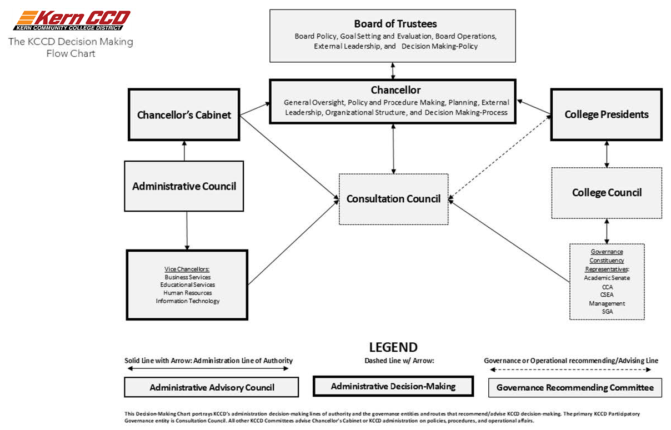

**Constituency Groups and Standing Sub-Committees**

|  |  |  |  |  |  |
| --- | --- | --- | --- | --- | --- |
| **Type** | **Purpose** | **Membership** | **Duration** | **Reporting Structure** | **Decision-Making Authority** |
| **Subcommittee** | Focuses on a specific aspect of a standing committee’s work. It exists to research, discuss, and make recommendations to the main committee. | Members of the parent committee and potentially additional subject-matter experts. | Long-term or ongoing as needed. | Reports back to the parent committee. | Advisory; does not make final decisions |
| **Workgroup** | A collaborative group formed to complete a specific task, project, or initiative, often cross-functional. | Can include faculty, staff, administrators, and students based on the project needs. | Temporary, until the specific task is completed. | Reports to the committee overseeing the project. | Advisory, unless granted authority for implementation. |
| **Taskforce** | Created to address an urgent or emerging issue that requires focused attention. | Selected based on expertise or role relevance. | Short-term, dissolved once the issue is resolved or recommendations are made. | Reports to the college president, College Council, or other governance body. | Can make recommendations, but does not implement policy. |

**How Are Committees Dissolved?**

Subcommittees: Can be dissolved by their parent committee when the issue is no longer relevant or has been incorporated into ongoing committee work.

Workgroups: Disbanded after completing their assigned task or project.

Taskforces: Automatically dissolved once they fulfill their charge or their recommendations are either accepted or rejected.

**Why Are Committees Created?**

Subcommittees: To break down complex governance topics into manageable parts.

Workgroups: To complete a specific initiative or research project requiring focused attention.

Taskforces: To address urgent or emerging issues requiring rapid action or expertise.

Who Can Create Them?

Subcommittees: Created by standing governance committees (e.g., College Council, Academic Senate, Budget Committee).

Workgroups: Formed by a department, administrative leader, or committee when collaboration is needed for a project.

Taskforces: Typically formed by the College President, College Council, or a major governance body to address time-sensitive issues.

Groups, by way of their senates and/or sub-committees, advise the president and/or the participatory governance representative committees on institutional decision-making and operations.

* President’s Cabinet
* President’s Advisory Council (PAC)
* College Council
  + Accreditation
  + Accessibility
  + Budget
  + Strategic Planning
  + Enrollment Management
  + Guided Pathways
  + Facilities Advisory
  + Informational Technology
  + Social Justice Action
* Academic Senate
  + Curriculum Committee
  + Equivalency
  + Outcomes Committee
  + Distance Education Committee
* Faculty Chairs
* Associated Students of Porterville College (ASPC)
* Kern CCD CSEA
* California College Association (CCA)

**Students**

Student representatives also are appointed to serve on all participatory-governance committees, a practice that adheres to the Title 5 Section 51023.7(a)(1) requirement that: “Students shall be provided an opportunity to participate in formulation and development of district and college policies and procedures that have or will have a significant effect on students. This right includes the opportunity to participate in processes for jointly developing recommendations to the governing board regarding such policies and procedures.”

Title 5 Section 51023.7(b) does specify the policies and procedures that “have or will have a significant effect on students” as follows:

• Grading policies;

• Codes of student conduct;

• Academic disciplinary policies;

• Curriculum development;

• Courses or programs which should be initiated or discontinued;

• Processes for institutional planning and budget development;

• Standards and policies regarding student preparation and success;

• Student services planning and development;

• Student fees within the authority of the district to adopt;

• Any other district and college policy, procedure, or related matter that the district governing board determines will have a significant effect on students.

Title 5 Section 51023.7(c) requires that the Board “give reasonable consideration to recommendations and positions developed by students regarding district and college policies and procedures pertaining to the hiring and evaluation of faculty, administration, and staff.” All student appointments to college governance bodies are made by the Associated Students of Porterville College.

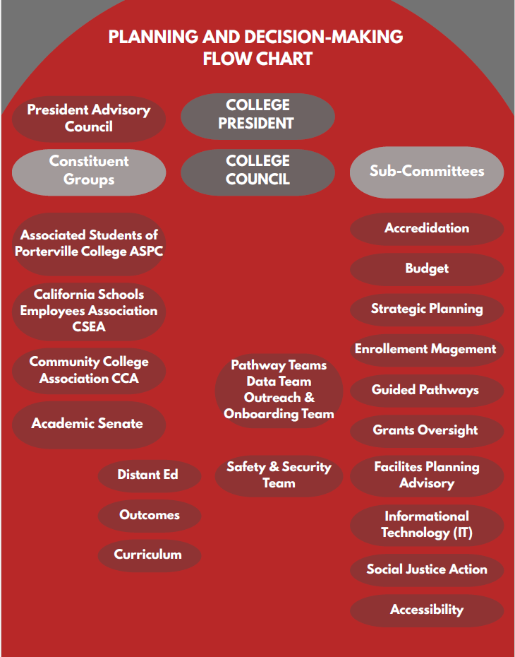

**Appendix A: Ed Code**

CALIFORNIA ED CODE, TITLE 5, AB 1725, & ACCREDITATION STANDARDS RELATED TO PARTICIPATORY GOVERNANCE

**California Education Code Section 70901(e)**

California Education Code, Section 70901(e) requires that governing boards of community college districts establish minimum standards for governing procedures to ensure that faculty, staff, and students the right to participate effectively in district and college governance. Governing boards must also establish minimum standards for governing procedures to ensure that faculty, staff, and students have the opportunity to express their opinions at the college-level and to ensure that these opinions are given every reasonable consideration. This section of California Education Code also designates the right of academic senates to assume primary responsibility for making recommendations in the areas of curriculum and academic standards. Title 5 § 53203 of California Code of Regulations Title 5 § 53203 states requirements for the “effective participation” of students and staff in the development of recommendations to the governing board. This section also requires the governing board to “consult collegially” with the academic senate (i.e., rely primarily upon the advice and judgement of the academic senate or reach mutual agreement between the governing board/designee and representatives of the academic senate) on academic and professional matters. Title 5 § 53200 defines “academic and professional matters” as 11 matters related to policy development and implementation. This agreement means that faculty undertake these duties to consult collegially on the 10+1 as a part of their faculty obligation.

**Assembly Bill 1725**

Assembly Bill 1725 is comprehensive California community college reform legislation passed in 1988 that covers community college mission, governance, finance, employment, accountability, staff diversity and staff development. This bill established the Academic Senate’s role as the college’s primary voice of the faculty in 36 providing recommendations to the governing board on academic and professional matters. Assembly Bill 1725 is operationalized in Title 5, as described in the section above.

**Accreditation**

Accrediting Commission for Community and Junior Colleges (ACCJC)

Standard 4: Governance and Decision-Making (June 2024)

The institution engages in clear and effective governance practices that support the achievement of its mission. Governance roles and responsibilities are delineated in widely distributed policies, and institutional decision-making processes provide opportunities for meaningful participation and inclusion of relevant stakeholders.

Standard 4.2. Roles, responsibilities, and authority for decision-making are clearly defined and communicated throughout the institution. The institution’s structure for decision-making provides opportunities for stakeholder participation and ensures the inclusion of relevant perspectives.

Standard 4.3. The institution’s decision-making structures are used consistently and effectively. Institutional decision-making practices support a climate of collaboration and innovation that advances the mission and prioritizes equitable student outcomes.



**Appendix B: BROWN ACT**

[The Ralph M. Brown Act](https://oag.ca.gov/system/files/media/the-brown-act.pdf) is a “public access law” that ensures the public’s right to attend the meetings of public agencies, facilitates public participation in all phases of local government decision-making, and curbs misuse of the democratic process by secret legislation. Under the Act, all meetings of local legislative bodies are open and public, and all persons are permitted to attend the meetings. Statutory exceptions authorizing closed sessions are construed narrowly, and the Brown Act “sunshine law” is construed liberally in favor of openness in conducting public business. (98 Cal.Ops.Atty.Gen. 41 (2015).)

Modeled after the Brown Act, the [Bagley-Keene Open Meeting Act](https://oag.ca.gov/system/files/media/bk-open-meeting-act-guide-2024.pdf) directs that state body meetings are open and public and all persons are permitted to attend any state body meeting except as otherwise provided. Its purpose is to allow the public to attend and participate as fully as possible in a state body’s decision-making. (103 Ops.Cal.Atty.Gen. 42 (2020).) The public’s right to open meetings is not only guaranteed by the Act but is enshrined in the California Constitution. (Cal. Const., art. I, § 3(b).) The updated Bagley-Keene Open Meeting Act Guide (2024) summarizes California law governing state boards and commission. The one-hour training video describes the various requirements of the Bagley-Keene Act.

The Brown Act, Open Meetings for Local Legislative Bodies (2003) summarizes California law governing local boards and commissions.

|  |  |  |  |
| --- | --- | --- | --- |
| Committee/Group | Brown Act | Not Brown Act | Open Meeting Act |
| Academic Senate | X |  | X |
| Curriculum Committee | X |  | X |
| Outcomes | X |  | X |
| Equivalency |  | X |  |
| College Council | X |  | X |
| Distance Education | X |  |  |
| Accessibility |  | X |  |
| Accreditation |  | X |  |
| Budget |  | X |  |
| Strategic Planning |  | X |  |
| Enrollment Management |  | X |  |
| Guided Pathways |  | X |  |
| Information Technology |  | X |  |
| Facilities Planning |  | X |  |
| Safety and Security Team |  | X |  |

Appendix C: Planning Document Matrix

|  |  |  |  |  |  |  |  |  |  |  |  |  |  |  |  |  |  |  |  |  |  |  |  |  |  |  |  |
| --- | --- | --- | --- | --- | --- | --- | --- | --- | --- | --- | --- | --- | --- | --- | --- | --- | --- | --- | --- | --- | --- | --- | --- | --- | --- | --- | --- |
| **Planning Document** | | | **Purpose** | | | | | **Details** | | | | | | | | | | | | | | **Access Link** | | | | | |
| **Integrated Planning, Assessment, and Action (IPAA) Document** | | Outlines planning processes, including activities, plans, calendars, and timelines. | | | | | | | | Adopted in Fall 2012, updated in 2023, serves as a foundational guide for institutional planning. | | | | | | | | | | | [IPAA Document](https://www.portervillecollege.edu/_resources/assets/pdfs/Research/01-planning-documents/IPAA%20Model2023.pdf) | | | | | | |
| **Educational Master Plan (2023–2028)** | Defines vision and goals for instructional programs, student support services, facilities, technology, and staffing. | | | | | | | | | | Aligned with the District Strategic Plan and the CCCCO Vision for Success Goals. | | | | | | | | [Educational Master Plan](https://www.portervillecollege.edu/_resources/assets/pdfs/Research/01-planning-documents/Porterville%20College%20EMP%20Final%202023.pdf) | | | | | | | |
| **Facilities Master Plan (2024–2029)** | | Provides a framework for physical modifications to the campus. | | | | | | | | Guides long-term land and building use, supporting academic and student support services. | | | | | | | | | | | [Facilities Master Plan](https://www.portervillecollege.edu/_resources/assets/pdfs/Research/01-planning-documents/PC%20Facilities%20Master%20Plan%202024-2029.pdf) | | |
| **Information Technology Plan (2024–2028)** | Outlines the strategic direction for IT infrastructure and services. | | | | | | | | Focuses on leveraging technology for education, administration, and student engagement. | | | | | | | | | | | [Information Technology Plan](https://www.portervillecollege.edu/_resources/assets/pdfs/Research/01-planning-documents/Poterville%20College%20InformationTechnology%20Plan%202024-28.pdf) | | | | | |
| **Kern Community College District (KCCD) Functional Map** | | Illustrates the distribution of services between the district and colleges. | | | | | | | | Clarifies centralized and decentralized functions; updated June 2018. | | | | | | | | [KCCD Functional Map](https://www.portervillecollege.edu/about-pc/research/planning-documents.html) | | | | | | | |
| **KCCD Strategic Plan** | | | | | Establishes district-wide goals in alignment with CCCCO Vision for Success. | | | | | Updated in 2023; provides a cohesive strategy for all colleges in the district. | | | | | | | [KCCD Strategic Plan](https://www.portervillecollege.edu/_resources/assets/pdfs/Research/01-planning-documents/09_TheElementsOfDecisionMakingDocument.pdf) | | | | | | | | | |
| **Participatory Governance at Porterville College** | | | | Details governance processes, including roles and responsibilities of staff and students. | | | | | | | | Emphasizes collaborative decision-making and inclusive practices. | | | | Participatory Governance Document | | | | | | | | |
| **Program Review Process** | | Evaluates academic and support programs to ensure quality and relevance. | | | | | | | | | | | Conducted at least every three years, informs planning and budgeting. | | | | [Program Review Information](https://www.portervillecollege.edu/about-pc/research-and-planning/program-review.html) | | | | | |
| **Staff Development Plan** | | | | | Addresses professional development needs for staff. | | | | | | | | Developed in 2018–2019; focuses on enhancing staff competencies. | | [Staff Development Plan](https://www.portervillecollege.edu/about-pc/research/planning-documents.html) | | | | | | | | |
| **Strategic Planning Calendar** | | | | | | Schedules strategic planning activities. | | | | | | | Provides a timeline for coordinated planning efforts across the institution. | [Strategic Planning Calendar](https://www.portervillecollege.edu/_resources/assets/pdfs/Research/01-planning-documents/14_StrategicPlanningCalendarRevised_9_12_17.pdf) | | | | | | | | | | | |
| **Student Equity Plan** | | | | | | | Addresses disparities in student achievement. | | | | | | Focuses on closing achievement gaps through targeted interventions and support services. | | [Student Equity Plan](https://www.portervillecollege.edu/_resources/assets/pdfs/student-equity/02_StudentEquityPlanPortervilleCollege2022-25.pdf) | | | | | | | | | | |



**Appendix D: Participatory Governance Matrix**

Process from the idea through the final decision for a variety of decisions that are made on campus.

|  |  |  |  |  |  |
| --- | --- | --- | --- | --- | --- |
| Task | Origin | Review, Discussion | Recommending Body | Final College Approval | Final Decision |
| Annual Planning Activities | Educational Master Plan; Program Reviews; Outcomes; Professional Development; Academic Senate | College Council | College Council | College President | KCCD Board of Trustees |
| Budget | District Budget Committee | Budget Committee | College Council | College President | KCCD Board of Trustees |
| Grants | Grant Proposer | Grant Subcommittee; Budget Committee | College Council | College President | District Leadership  KCCD Board of Trustees |
| Committee work | [Accreditation](https://committees.portervillecollege.edu/accreditation/index.html)  Accessibility  [Budget](https://committees.portervillecollege.edu/budget-committee/index.html)  [Strategic Planning](https://committees.portervillecollege.edu/strategic-planning/index.html)  [Enrollment Management](https://committees.portervillecollege.edu/enrollment-management-committee/index.html)  [Guided Pathways](https://committees.portervillecollege.edu/guided-pathways-committee/index.html)  [Information Technology](https://committees.portervillecollege.edu/it-committee/index.html)  [Facilities Planning](https://committees.portervillecollege.edu/facilities-planning-advisory-sub-committee/index.html)  [Safety and Security Team](https://committees.portervillecollege.edu/safety-and-security-team/index.html)  [Social Justice Action](https://committees.portervillecollege.edu/social-justice-action-committee/index.html)  [Staff Development](https://committees.portervillecollege.edu/staff-development-committee/index.html) | College Council and/or Academic Senate | College Council and/or Academic Senate | College President | District Leadership  KCCD Board of Trustees |