Enrollment Management Minutes

3:00pm – 4:00pm  February 12, 2024  AC-120

Our Mission
With students as our focus, Porterville College provides our local and diverse communities quality education that promotes intellectual curiosity, personal growth, and lifelong learning, while preparing students for career and academic success.

Attended: Thad Russell, Michelle Miller-Galaz, Osvaldo Del Valle, Mike Carley, Elizabeth Keele, Kendra Haney, Frank Ramirez, Ethan Hartsell, Matthew Flummer, Rebecca Baird, Debbie Angeles, Stephanie Olmedo-Hinde, Melissa Long, Kim Behrens Kristen Plunk.

- Call to Order 3:03 pm
- Approval of Agenda
M/S/C: E. Keele/ M. Flummer

- Approval of Minutes
M/S/C: E. Keele/ M. Long

- Full audience - Information Items
- Banner 9 Update: No Update

- Student Services Updates: Request for Progress reports sent out today. Deadline for completion is Tuesday February 20, 2024. Remind instructors to input grades and comments. Students will get an email with grades and comments unless box is clicked to keep comments internal. Only have 75% response rate and need to get this higher.

- Counseling Update: No Update.

- Full audience - Discussions Items
      - a Summer Session Process Proposal: Block summer schedule (see chart below). This will move onto College Council.
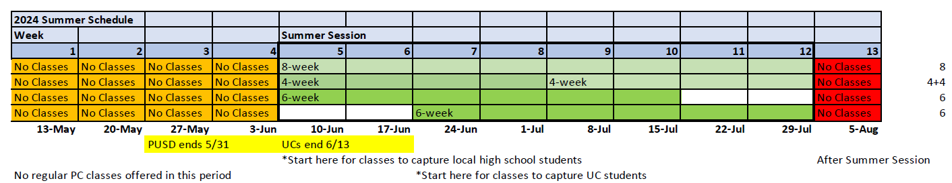

      - b Enrollment Management Plan: Taskforce members remained in the meeting to continue development and revision of the plan.

- Other

- Future Agenda Items:

- Adjourn 3:29 pm

- 2017-2022 Enrollment Management Goals
  - Increase number of declared majors
  - Increase awareness of instructional program offered
  - Increase the number of dual enrollment offerings and track the success of those offerings
  - Increase the percentage of students who take 15 units per semester
  - Increase percentage of students who complete 30 units by end of 1st year of college
  - Increase awareness of career options within programs/pathways of study
  - Increase the number of students receiving associate degrees and certificates
  - Increase number of students who transfer to university
  - Increase number of students with ready resume, job applications

