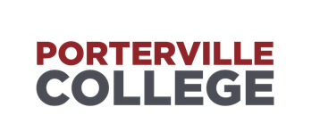
Strategic Planning Committee
Minutes
2:00 PM – 3:00 PM – April 3rd, 2024 - L-405

Accessibility Note: If you are an individual with a disability and need accommodation.
please contact Ayla Mora 559-791-2298
Present: Michael Carley, Patty Serrato, Osvaldo Del Valle, Jodie Logan, Mallory Brown
Guest: Lisa Prieto, Erin Wingfield

- Call to Order: Michael Carley called to order at 2:07pm
- Approval of Agenda: Jodie Logan/Patty Serrato
- Approval of Minutes: N/A
- Discussion Items

- Student Health and Wellness

The committee reviewed and discussed the following sections of the program:

The committee suggested looking over the format of the document, including headers.

Program Mission Statement: The committee agreed it meets requirements.

SAOs: Possibly add that the survey is taking place this semester.

Data: The committee suggested adding minor grammar corrections. Maybe change wording from “visits” to “appointments”. Committee suggested moving header from page two to page four after the charts.

Changes in Program in the Last Three Years: The committee agreed this section meets requirements.

Report on Previous Goals: Nothing to report.

Strengths and Areas of Improvement: Committee agreed this section meets criteria.

Goals: Committee agreed this section meets criteria.

Staffing Requests: Committee agreed this section meets criteria.

Resources Requests: Committee agreed this section meets criteria.

Budget: The committee suggested including funding for professional development conferences.

- Announcements

- Future Agenda Items
Language Arts Department Program Review

Meeting Adjourned: 2:51pm
Next scheduled meeting at LIB 405: April 17th 2024 at 2:00pm

