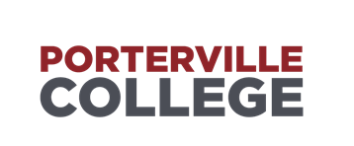

Strategic Planning Committee
Minutes
1:00 PM – 2:00 PM November 30th, 2022 – L-405

Accessibility Note: If you are an individual with a disability and need accommodations.
please contact Ayla Mora 559-791-2298

Present: Melissa Long, Mallory Brown, Osvaldo Del Valle, Michael Carley
Guest: Erin Wingfield, Katherine Figueroa

- Call to Order: Michael Carley at 1:05pm
- Approval of Agenda: M/S Mallory Brown/Melissa Long
- Approval of Minutes: M/S Melissa Long/ Mallory Brown
- Discussion Items
Veteran’s Center Program Review
-The committee agreed that the Program Mission meets standard.
- On Service Area Outcome section, the committee suggested small grammar edits. Also, to include when the last SAO assessment was inducted. The committee also suggested sending out the satisfaction survey every three years instead of every year. Committee agreed the rest of the section meets standard.
-The committee agreed that the Program analysis and Trends Program Mission meets standard.
-The committee suggested to change Data Review section to a passive voice.
-The committee suggested to resolve small grammar errors and to include goals in the Strengths and Areas of Improvement section. Committee agreed the rest of the section meets standard.
In Resources Requests section the committee advised to mention if the department has funding for sections even when not requesting.

- Announcements
- Future Agenda Items

Adjournment: 1:52pm
Next scheduled meeting –January 17th 2024- L-405

